North Connemara Covid-19 Commemoration
Sunday, March 20th 2022, 6.30PM
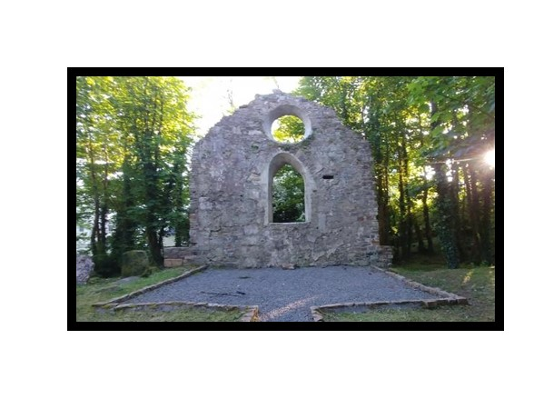
In fond memory …. I nDíl Chuimne
of all those who died during the Covid-19
pandemic March 2020 – March 2022

Welcome from the Chairperson

We welcome you all to this North Connemara Covid-19 Commemoration ceremony in Clifden.
Aodán McGlynn, Musical Director of the Cantairí Chonamara Choir for many years, conceived the idea for this event to remember all those who died during the Covid-19 pandemic.
This ceremony provides an opportunity for all those who suffered the loss of loved ones to come together and mark their passing, in a way that was often not possible at the time, due to the strict Covid-19 restrictions in place. We seek also to acknowledge the sacrifices made by so many in the interests of the greater good of safeguarding the wider public health at a very difficult time.
Cantairí Chonamara lost one of its own much-loved members, Claudine Knight, who died tragically young on 7 May 2021. This ceremony is also the choir’s own tribute to Claudine, as the full choir was not permitted to sing at her funeral.
There may also be a much wider sense of loss in the surrounding community of North Connemara with 165 funerals in the region over the two years of the Covid-19 pandemic and families unable to follow the usual rituals of mourning and remembrance.
St. Mary’s is the oldest graveyard in Clifden and we thank Fr. James Ronayne for permission to hold the commemoration in this beautiful and atmospheric location. A commemorative yew tree, and nearby seat, specially commissioned for this event, will provide a permanent place for residents and visitors to pause, reflect and remember their own loved ones no longer with us. Anyone who wishes may write the names of their loved ones on tags to attach to the metal surround around the yew tree.
We aim to remember all those who died during the pandemic, whether of Covid-19 or other causes and to acknowledge the sacrifices made by their families, medical staff to protect public health and all the wider front-line workers who maintained essential services in very difficult circumstances.
So we welcome all those who have joined us in commemoration this evening and as we sing that great hymn, ‘Abide With Me’, arranged for the choir in Claudine’s memory by Dr. Mark Keane, we hope and pray that the memory of loved ones who have passed away will always abide with us.
Ar dheis de go raibh a anam.

From Minister for Health, Stephen Donnelly
‘In the last two years, we have been challenged in many different and diverse ways as our country’s response to COVID-19 evolved on an ongoing basis.
We have lost loved ones at times when it was not possible to fully celebrate their lives as we would have liked, we have isolated and restricted our movements in order to protect each other and ourselves, we have postponed and cancelled the events in life that we most look forward to celebrating with our friends, families and wider communities like birthdays, anniversaries, weddings and graduations.
We were faced with the reality that our individual behaviours held potential consequences for our family and friends. We also know that co-ordinated efforts by our communities would be required if we were to overcome the threat posed – we needed collective action, we needed solidarity and we needed to harness our meitheal spirit.
Across Ireland, and of course here in Galway, as communities, we came together by staying apart, performing guards of honour at a social distance, moving meetings and community get-togethers online, but never losing our spirit of collectiveness and connectedness that is the very fabric of community life in Ireland.
Our collective efforts in following public health advice, along with the exceptionally high vaccination uptake across the country, have seen us weather the latest surge of infection, allowing us to look to the future with hope and positivity.
Today’s event is a wonderful example of how we can look to the future together, remembering all of those who lost their lives during the Covid-19 pandemic, our front-line health and other essential workers who sacrificed so much to keep our society moving and, importantly, reminding ourselves that we have a great challenge to protect the renewed sense of community created by the pandemic.
Guím gach rath ar an ocáid inniu agus ar Phobal Chonamara Thuaidh amach seo – treise libh.’
(I wish the event today and the Community of North Connemara every success in the future - congratulations to you.)

Order of Ceremony

Choir: Mozart Requiem ‘Introit’ Soloist: Úna McGlynn
Official Welcome/Fáiltiú from Councillor Eileen Mannion
Reading 1: Book of Wisdom Chapter 3 v.1 – 6, 9 Reader: Nurse Annette Fahy
Sean-Nós Lament: ‘Úna Bhán by Deirbhile Ní Bhrolcháin
Reading 2: 'On Passing a Graveyard' by Fr. John O’Donoghue Reader: Maria Cribbens
Choir: Mozart Requiem ‘Lacrimosa’
Reading 3: St. John’s Gospel Chapter 14 v.1 – 6 Reader: MJ Ferron
Choir: Philip Stopford ‘In My Father’s House’
Tree planting John Sweeney, Chamber of Commerce
Reading of names, family members of loved ones to attach name tags.
Choir: Karl Jenkins: ‘Pie Jesu’, Bruckner: ‘Locus Iste’, Stopford: ‘Do Not Be Afraid’
One minute’s silence and remembrance.
‘Abide with me’ arr. Dr Mark Keane - all to join in singing with the choir
‘Thank you’ and ‘Slán abhaile!’
‘Requiem’ by W.A. Mozart, soloist Úna McGlynn.
In an ‘ómós’ to tradition, W.A. Mozart begins his ‘Requiem’ in a low, march-like dirge but soon the choir soars up to the heavens to portray the peaceful perpetual light and a single voice representing all the dead confirms that they are now in the heavenly Zion, singing hymns of praise to God.
The choir then once again reiterates, ‘Requiem aeternam dona eis, Domine’ - Lord, May they rest in peace, our prayer also today.
Requiem aeternam dona eis, Domine,  et lux perpetua luceat eis.  Te decet hymnus, Deus, in Zion,  et tibi reddetur votum in Jerusalem.  Exaudi orationem meam,  ad te omnis caro veniet.  Requiem aeternam dona eis, Domine,  et lux perpetua luceat eis. | Grant them eternal rest, O Lord,  and may perpetual light shine on them.  Thou, O God, art praised in Zion,  and unto Thee shall the vow  be performed in Jerusalem.  Hear my prayer, unto Thee shall all flesh come.  Grant them eternal rest, 0 Lord,  and may perpetual light shine on them.

Official Welcome/Fáiltiú

A reading from the Book of Wisdom Chapter 3 v. 1-6, 9
The Book of Wisdom is found in Roman Catholic bibles between the Old and New Testaments. In this remarkable passage the Greek idea of every living being having a ‘soul’ and the Judeo-Christian idea of an after-life with God come together. The souls of the just are in the hands of God, it proclaims, we should not then be anxious or worrying about them.

The souls of the virtuous are in the hands of God, no torment shall ever touch them.

Yes, in the eyes of the unwise, they did appear to die, their going looked like a disaster, their leaving us, like annihilation, but they are at peace.

If they experienced punishment as men see it, their hope was rich with immortality.

Slight was their affliction, great will their blessings be.

God has put them to the test and proved them worthy to be with him;

He has tested them like gold in a furnace, and accepted them as a holocaust (sacrificial offering) ??

They who trust in him will understand the truth, those who are faithful will live with him in love;
for grace and mercy await those he has chosen (and he watches over them)??

Úna Bhán, Lament sung by Deirbhile Ní Bhrolcháin
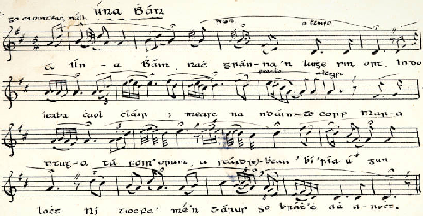
Transcription above by Séamus Ennis Source: Tomás Mac Eoin English Translation: Deirbhile Ní Bhrolcháin

Úna Bhán | O Fair Una
In uaigneas na cille nach fuar é an oíche anocht!  Ach ní mó an fuacht ná an buaireamh ‘tá i mo chroí-se istigh  I gcónra chaol chláir tá mo ghrá ina lui ‘na corp,  Tá an t-am seo ró-mhall le do chás a leigheas anois.  A Úna Bhán, nach gránna an lui é sin ort  Do cheann le fán i measc na gcéadta corp  A Úna a mhúirnin, a phlandóigin a bhí riamh gan locht  Mura dtabharfaidh tú aird orm, ní thiocfaidh mé’n turas seo go brách, ach ar oíche anocht.  A shúile ba ghlaise ná deora ‘tá ag sileadh liom síos  A cheobh ba ghile ná an sneachta dhá cháitheadh le gaoth,  A ghuth ba bhinne ná ceol n-éan ar chraobh  A mhúirnin ‘s a chumain, nach minic do bhuaireamh triom.  A Una Bhán ba rós i ngáirdín thú,  Ba choinnleoir óir ar bhord na banríon’ thú,  Ba cheiliúr ‘s ba cheolmahar ag gabháil an bhealaigh romham thú,  Sé mo chreach is mo bhrón nár pósadh le do ghéarghra thú.  A Úna Bhán, ó is tú d’fhág mé gan chiall,  A Úna, is tú do chuaigh go dlúth idir mise ‘gus Dia  A Úna a’ chraobh chumra, a lúibín chasta na gciabh  Nár bhfearr domsa bheith gan súll ná tú a fheiceáil ariamh. | In the loneliness of the churchyard, isn’t tonight a cold night,  But the cold is no greater than the sadness in my heart,  In a cold, narrow coffin my beloved lies as a corpse,  It is too late now to improve your situation.  O fair Una, isn’t it an awful place you are lying,  Your head on a slope among hundreds of corpses;  O Úna, my beloved, beautiful girl ever without fault,  If you don’t heed me, I will not come on this journey ever again, but for tonight.  O eyes brighter than the tears that are falling from me,  O side that was whiter than a snowdrift blown by the wind,  O voice that was sweeter than the music of the birds on a branch,  My beloved, my darling, isn’t it often that the sadness caused by you goes through me.  O fair Una, you were a rose in a garden,  And you were a gold candlestick on the queen's table;  You were melodious and musical as you walked the path before me,  It is my huge loss and sadness that you were not married to your beloved.  O fair Una, it is you who left me bewildered,  O Una, it is you who went strongly between me and God;  O Una, o fragrant branch, o curly ringlet of tresses,  Wouldn't it have been better for me to be blind than ever to have seen you?

'On Passing a Graveyard' by Fr. John O’Donoghue

May perpetual light shine upon
The faces of all who rest here.

May the lives they lived
Unfold further in spirit

May all their past travail
Find ease in the kindness of clay

May the remembering earth
Mind every memory they brought

May the rains from the heavens
Fall gently upon them

May the wildflowers and grasses
Whisper their wishes into light

May we reverence the village of presence
In the stillness of this silent field.

Choir: ‘Lacrimosa’ from Requiem by W.A. Mozart
The death of Mozart bore many similarities to some of the early Covid-19 funerals. A streptococcal infection, contracted possibly from eating pork or wild hare, had ravaged through his body. While singing through his latest composition, ‘Lacrimosa (Tears)’, with his friends, he broke down and cried when he realised that this was his last work. Within hours he was dead. The body was rushed out of the house, out of the cathedral without a funeral mass and buried in an unmarked grave without his wife or family being present.

Lacrimosa dies illa  Qua resurget ex favilla  Judicandus homo reus.  Huic ergo parce, Deus:  Pie Jesu Domine,  Dona eis requiem. Amen. | Full of tears will be that day  When from the ashes shall arise the guilty man to be judged;  Therefore spare him, O God:  Merciful Lord Jesus, Grant them eternal rest. Amen

A reading from the Gospel of St. John, Chapter 14 v. 1-6
The promise of Jesus to prepare a place for us in the father’s house has a family intimacy about it that gives great hope.
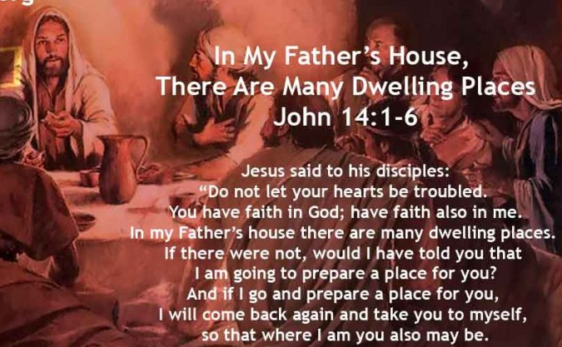
Choir: ‘In My Father’s House’ by Philip W.J. Stopford
In my Father’s house are many dwellings, And if I go to prepare a place for you,
I will come back again and take you to myself, So that where I am, you also may be.

Do not let your hearts be troubled, You have faith in God, have faith also in me.
In my Father’s house are many dwelling places.
If there were not, would I have told you I am going to prepare a place for you?

Where I am going, you know the way, Where I am going you know the way.
For I am the way, the truth and the life;
No-one comes to the Father except through me. If you know me, you also know my Father.

My spirit will be with you always
The Advocate, the Spirit of Truth will remind you of all I have said.

Peace I leave with you; my peace I give to you.
Do not let your hearts be troubled; do not be afraid.
I have told you I will come back to you; have faith in me.

Tree planting
Reading of names, and family members may attach the names of their loved ones to the tree surround.
The choir will sing Karl Jenkins: Pie Jesu and Anton Bruckner: Locus Iste

The Irish yew tree is a native tree which the Druids held sacred in pre-Christian times. The tree’s qualities of great longevity and capacity to regenerate itself were greatly valued.

Drooping branches of old yew trees can root and form new trunks where they touch the ground. Thus the yew came to symbolise death and resurrection and is frequently found in graveyards.

Excerpt from Morte d'Arthur by Alfred, Lord Tennyson

‘… But now farewell.’
So said he, and the barge with oar and sail
Moved from the brink.

Long stood Sir Bedivere
Revolving many memories, till the hull
Look'd one black dot against the verge of dawn,
And on the mere the wailing died away.’

Tied, as it were, to the Commemoration Yew Tree, we have a meditation bench in the form of the transom of a rowing boat. Visitors may like to sit and envision themselves sharing that last journey of their loved ones, to articulate the things they may have wanted to say to them, but perhaps did not get that opportunity.....’Revolving many memories’.

A minute’s silence to honour the dead...

‘Abide with me’ by Henry Francis Lyte arr. Dr Mark Keane
‘Abide with Me’ was written by Lyte in 1847 as he was dying from tuberculosis. It is most often sung to the tune "Eventide" by the English organist William Henry Monk. It is a prayer for God to stay with the speaker throughout life and in death. The hymn became popular during WW1 for the great hope it proclaims in the midst of devastation. This choral arrangement by Dr. Mark Keane was made in honour of choir member, Mrs Claudine Knight R.I.P. 7th May 2021.

Abide with Me H.F. Lyte and W.H.Monk

Abide with me, fast falls the eventide
The darkness deepens Lord, with me abide
When other helpers fail and comforts flee
Help of the helpless, oh, abide with me
Swift to its close ebbs out life's little day
Earth's joys grow dim, its glories pass away
Change and decay in all around I see
O Thou who changest not, abide with me
Hold Thou Thy cross before my closing eyes
Shine through the gloom and point me to the skies
Heaven's morning breaks, and earth's vain shadows flee
In life, in death, o Lord, abide with me
In life in death, o Lord, abide with me.

‘They are blessed who wait upon the Lord,
Who serve him, who serve the Lord our God.
For they shall walk on earth and never tremble,
They shall soar with eagles’ wings to heaven;
Never more shall they be weary.’

The North Connemara Covid-19 Commemoration Committee would like to thank the many people who made this event possible.
Cantairí Chonamara Choir
Mark Keane, Musical Director, conductor and arranger of ‘Abide with me.’
Soloists Deirbhile Ní Bhrolcháin and Úna McGlynn
Community School teachers and Transition Year Student ushers,
Connemara Garden Club for advice on a suitable tree
Willy Duffy for designing and making the Commemoration seat.
Fr. James Ronayne for kind permissions to use the Old Graveyard location and for the site for the tree and seat.
Connemara Chamber of Commerce for the use of the town lights and Kevin Keogh for putting up lights.
Clifden Tidy Towns for their assistance in tidying the graveyard
Local councillors Eileen Mannion and Gerry King
The North Connemara Funeral Directors
Connemara Community Radio for their help in promoting the event
The Digital Office for printing and assistance with layout
Vincent Fahy and St. Joseph’s Stewards and Covid officers
Sharon O’Grady of the Galway County Council Arts Office for financial support
Sponsors: Paul Hughes for the commemorative seat; John Brendan Mannion for the commemorative booklet

North Connemara Covid-19 Commemoration Committee
Janet Mercer Chairperson and Cantairí Chonamara Chairperson
Aodán McGlynn Cantairí Chonamara event producer
Brian Thornburgh Cantairí Chonamara treasurer
Eileen Mannion Local Councillor
Gerry King Local Councillor
John Brendan Mannion Covid officer
Vincent Fahy Health and safety officer
Ann de Courcey Chamber of Commerce

